(2) Online Only Auctions

Erich J Harris Estate
Bidding Opens July 18 Grand River Antiques Bidding ends July 23 @ 7pm
Auction Located @ 411 Grand River Port Huron Mi. 48060
Some Highlights:
China Cabinets, Paintings, Glassware, China, Chairs, Leaded Windows, Lots of Period Lighting and Shades, Arts & Crafts, Oak Table, Reverse Painted Lamp and Much More 2 Floors of Antiques!
Do not miss BOTH online auctions

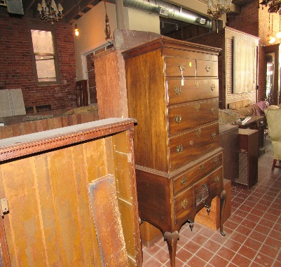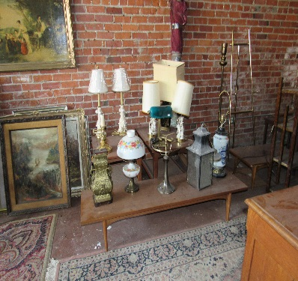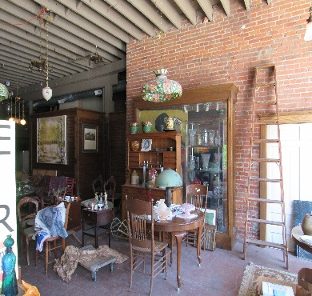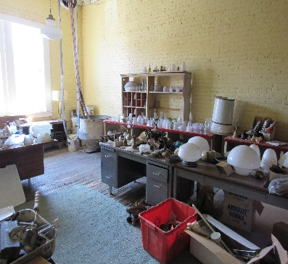
--------------------------------------------------
ONLINE AUCTION #2

Bidding Opens on July 25 Bidding will end July 30 @7pm
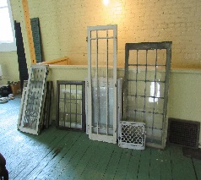
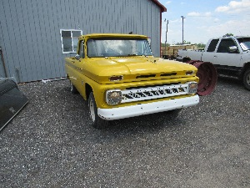
Auction Located @ 15536 Imlay City Rd. Capac Mi. 48014
Monthly Consignment Auction.
100s of Lots, 2 ESTATES
SEE WWW.TOSCHAUCTION.COM FOR Photos and More Information


Auction Conducted By:
Toschs Auction Service
Capac, Mi. 48014

For More Information:
www.toschauction.com
1-800-311-4985

