AUCTION
NH Baler Fulton Crock C&O
Furniture Tools Griswold Diamond Ring
Collectibles Sinclair H-C Gas Pump Cargo Trailer
**Everything sold ABSOLUTE except the Diamond Ring**
SATURDAY, October 10 – 10:00am
150 Denmark Farm Ln., Lexington, Va.
Go to www.nicelysauctionco.com for all info!!
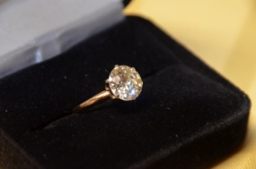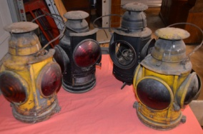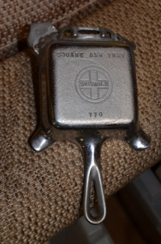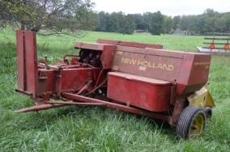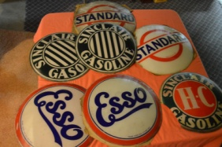
FARM EQUIP/LAWN & GARDEN: New Holland 311 square baler, 5th wheel trailer, 2 United Farm Tools 6 ton hay wagons, Grove Mod 505 hay wagon, Riding Mowers (LX176 John Deere 14hp wheel weights 38” cut; 2010 John Deere X500 54” wheel weights), plug aerator, front tine tiller, Ariens 5hp rear tine tiller SRT 5020, string trimmers, wheelbarrow, spreader, push mower, Murray edger+ JEWELRY: Diamond ring (14kt yellow gold 6 prongs round solitaire w/an approx. weight of 2.87ct.; European cut, consists of a 6 prong white gold head on a 2.5mm yellow gold pinch shank; has a clarity of 11 & color of M-N; stone has a medium-thin upolished girdle), pocket watches (Remington, Gruen, Westclox, Ball+), asstd. watches (Wittnauer+), German and U.S. compasses, belt buckles (Goodyear, CSX, Winchester, NRA, FOP+). COLLECTIBLES: Fulton crock (signed #186) & numerous other crocks/jugs/dispensers, Sinclair H-C gas pump, vtg. glass gas pump globe lenses (Esso, Standard, Sinclair), Griswold: Skillets (#3,#6, #7, #8, #9, #10 w/lid; bean pot w/lid, #8 griddle, #23 bread stick, ash tray w/Griswold pup+), cast 1920’s miniature bench w/old man & woman, cast Gamewell fire alarm box, footed cast scalding pot, small wood stove(Brown Stove Works), C&O (first aid kits, torch, lanterns, locks, keys, tie nails, dispenser+), knives (Case “Coal Miners” collectible, Browning, Old Timer, Frost, Robeson, Winchester, Uncle Henry+), Marlboro metal sign, old jars (Lance+), vtg. roadside emergency kit, Road Master bicycle, old bottles & jars (Peerless, Lance+), old wooden liquor

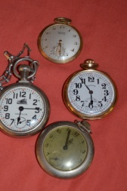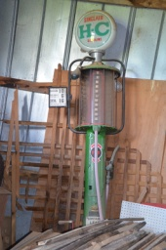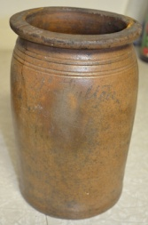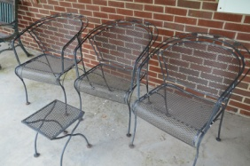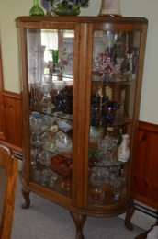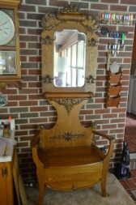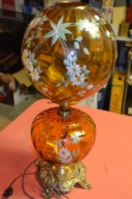
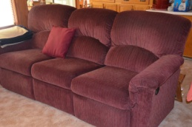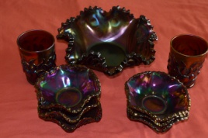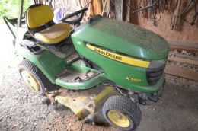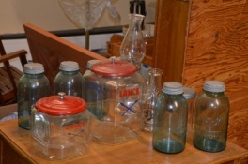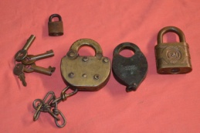
bottle, blue jars, wash board, Garden Way meat press, vintage glassware (pink depression, iridescent carnival, compotes, Fenton style+), 60’s Life magazines, Coca Cola items, butter churn, Daisy hurricane lamp & painted vases, silver plate & glass sugar cube jar, vtg. oil & vinegar cruet, Women’s Club ornaments, decanters, coffee grinders, Session mantle clock, doll stroller,Thomas radio, books, brass stencil. TOOLS/MISC: Hitachi chop saw, bottle jacks, Milwaukee HD hole hawg, chainsaws (Homelite Super XL, Stihl 031), Homelite 4400 generator, log splitter, pipe dies & cutters, Greenfield & Craftsman tap & die sets, pruners, c clamps, Craftsman cutting tool, can hook, pitchforks, post hole diggers, come-a-longs, chain hoists, clevis shackles, picks, numerous log chains, potato forks, hoes, shovels, rakes, copper plumbing fittings, nuts, bolts, screws, wrenches, sockets, horse shoes, game feeder, gun cases, Cabela’s travel bag, baskets, galvanized tubs, luggage, lay off plows, ext. cords, ladders, gas cans, 4’ fluorescent light bulbs, outdoor camping rug, live traps, speedway 2 in 1 jump start, folding aluminum table, canning supplies, coolers, lumber. ANTIQUES/FURNITURE: Oak hall tree, oak curved glass china cabinet, Pulaski curio cabinet, tea cart, Salterini style furniture (6 chairs, round table, end table), 2 benches, swing, oak wash stand, cherry drop leaf table w/4chairs, coffee table w/2 matching side tables, desk, floral couch, occasional tables, matching recliner couch & chair, 2 rocker recliners, Grandfather clock, church pew, retro kitchen cart, 6pc. Blonde bdrm. set, Lane & Lifetime cedar chests, 2 gun cabinets, oak (wall display, towel rack), wooden rocker. HOUSEWARES / MISC: Stoneware/ceramic dishes, electric fireplace stove, ice cream machine, slicers/meat grinders, ginger jars, rugs, lamps (stained glass, double globe+), Vision ware, holiday décor, gas grill, sm. appliances, microwave.
DIRECTIONS: I64E, exit 43 (Goshen), left onto Scenic View, rt. onto W.Midland Trail, go about 4 mi., follow signs; I64W, exit 50 (Kerrs Creek), left at end of ramp, rt. onto W.Midland Rd., follow signs.
TERMS OF SALE: Cash, check or charge (proc. fees apply) day of sale and picture ID required. Announcements day of sale take precedence over printed material. Food will be provided by Boiling Springs Fire & Rescue. Some chairs available or bring a chair.
NO BUYER’S PREMIUM!!
Sale conducted for the Chittum Estate by
NICELY’S AUCTION CO.
Brandon Nicely - Auctioneer #2620Va. Mike Jeffries – Auctioneer #4073Va.
425 Soldiers Retreat Rd., Eagle Rock, Va. 24085
540/968-2568 540/968-0962

