AUCTION
REAL ESTATE
5511 Dunlap Creek Rd., Covington, Va.
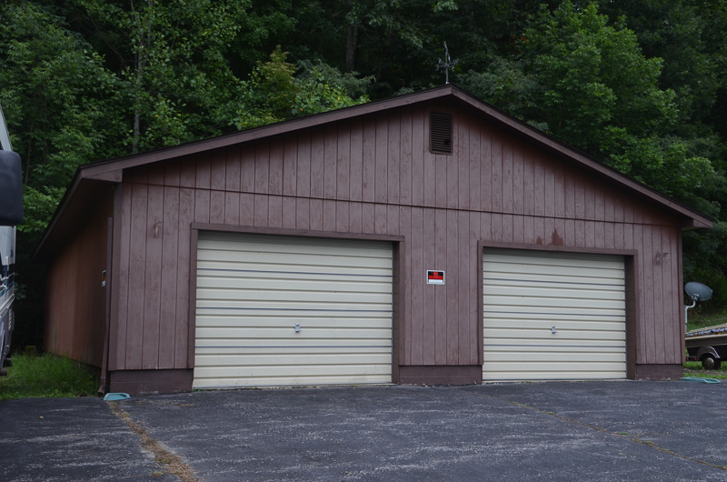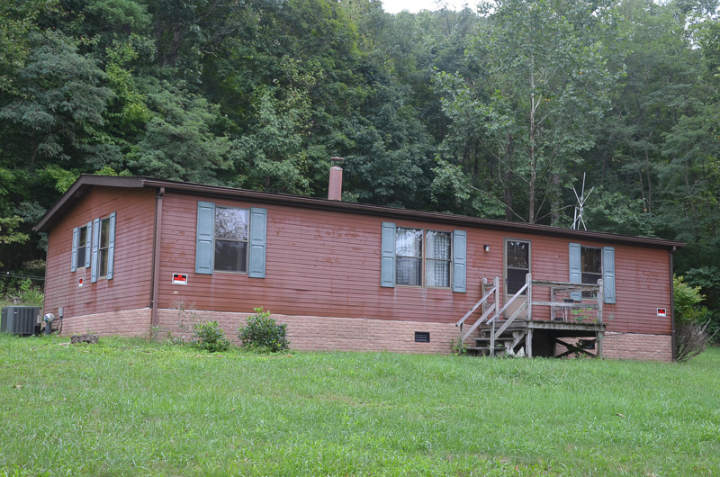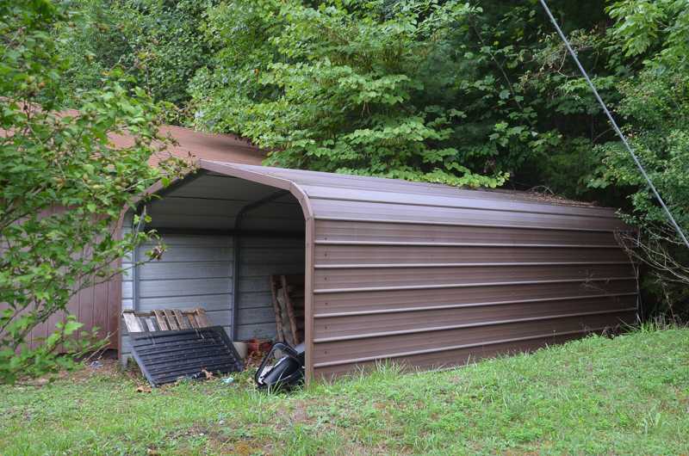
**Early Offers To Be Considered on RE**
PERSONAL PROPERTY:
1937 PLYMOUTH 1983 DODGE RAMPAGE 2.2 HONDA GOLDWING
FLEETWOOD MOTOR HOME JEWELRY (Men’s Diamond rings+)
COCA COLA/NASCAR FURNITURE/HOUSEWARES TOOLS++
SATURDAY, OCT. 2 – 10:00AM
DUNLAP FIRE DEPARTMENT
5519 Dunlap Creek Rd., Covington, Va.
(Home for sale is located next door to the Fire Dept.)
Go to www.nicelysauctionco.com for all info!!
Real Estate: 1296sf manufactured 1 story home on 2 lots (total of 2.37acres), 3 bdrms., 2 full baths, LR, DR, kitchen, rear deck, electric baseboard heat/AC (new heat pump), large detached 2 bay garage, metal carport, 2 wels & septic, refrigerator/stove/washer/dryer will convey.
Vehicles/Motorcycle: 1937 Plymouth 2 dr. coup: 1983 Dodge Rampage 2.2, 83,891mi.; 1998 Honda Goldwing motorcycle, 48,500mi.; 1994 Chevy Fleetwood motor Home, 85,295mi.
Jewelry: Men’s rings: 14kt. gold w/3diamonds (total weight 1ct.), 10kt. 1970 Alleghany County H.S. class ring and senior key; gold/onyx ring; 3 gold rings (2 w/diamond chips); necklaces/bracelets (GOLD, SILVER, Avon); ladies gold pendant w/Peridot colored stone; men’s watches (Pulsar, Timex+).
Collectibles: Bat Masterson Holster Set (complete w/cane and vest in orig. box); Coca Cola (vtg. coca cola machine, 4 vtg. metal coolers, bottle crates, cast bottle wall mount opener, bottle openers, bottles in 6 pack metal 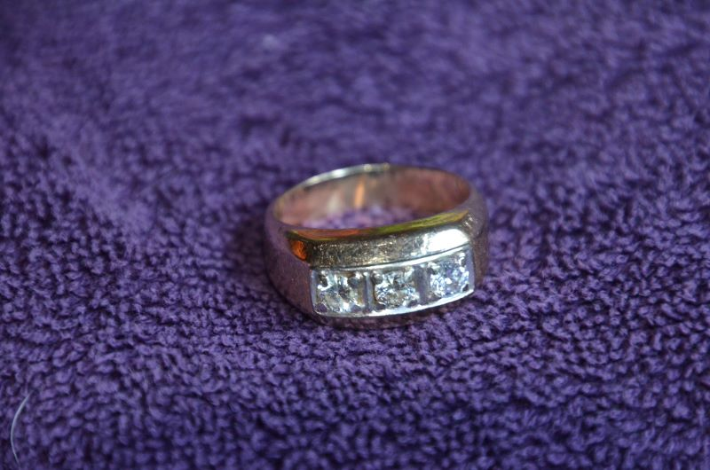 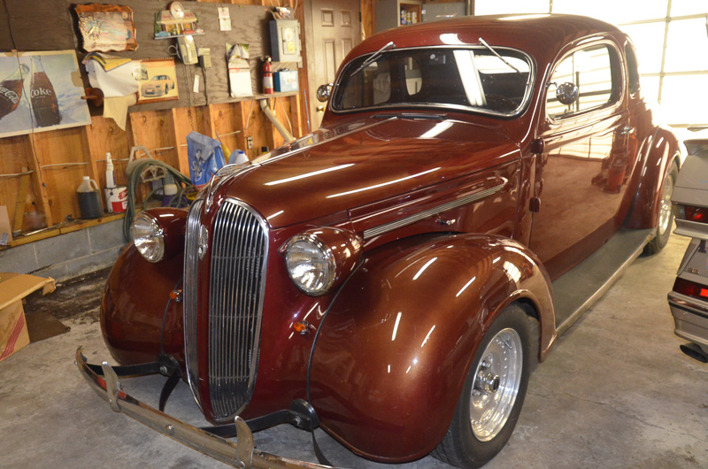 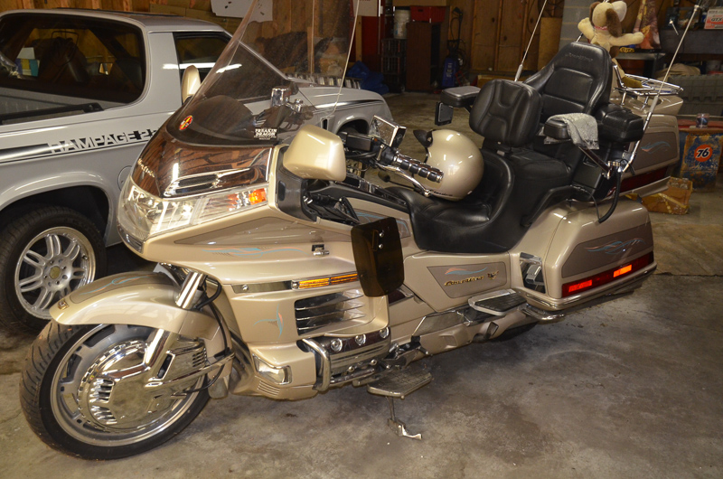 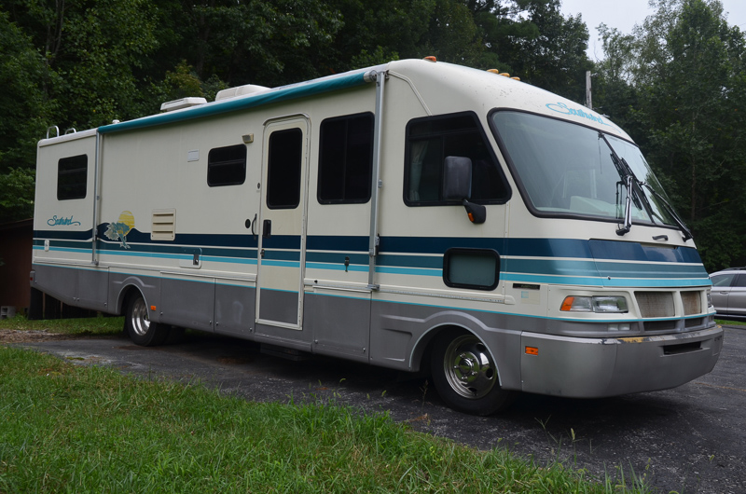 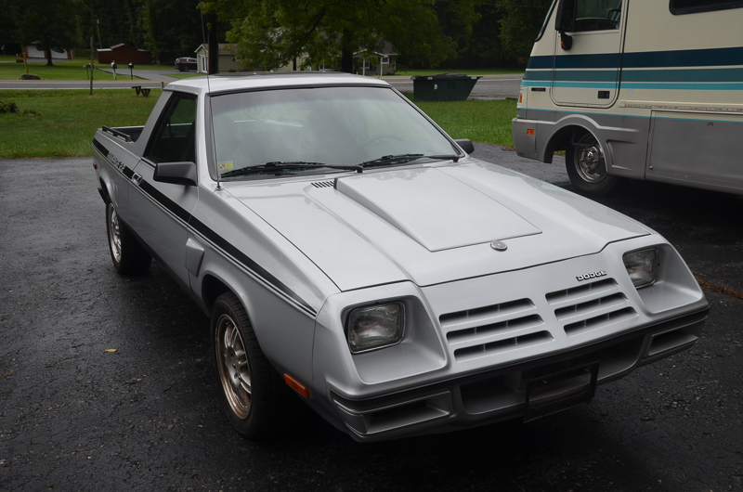

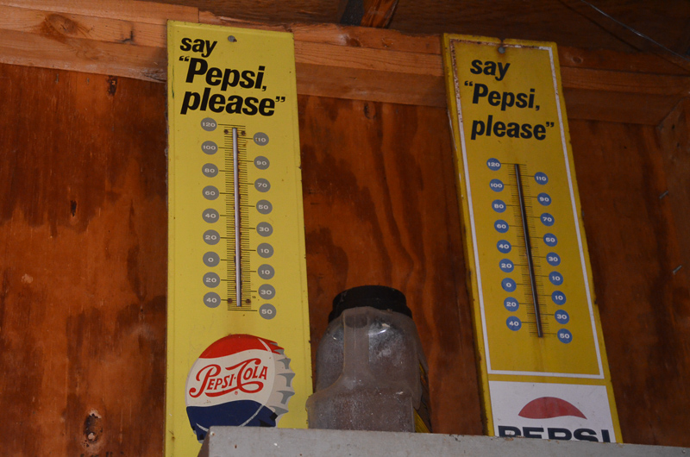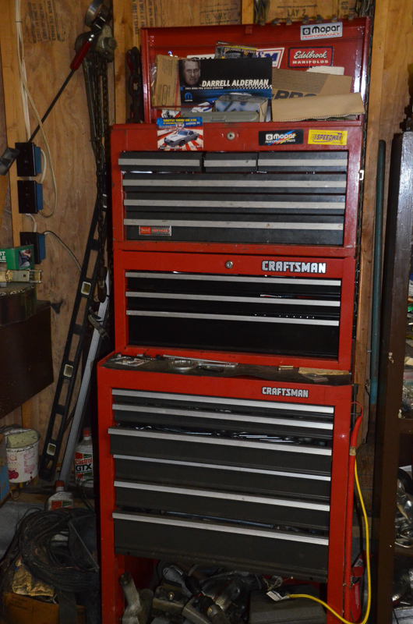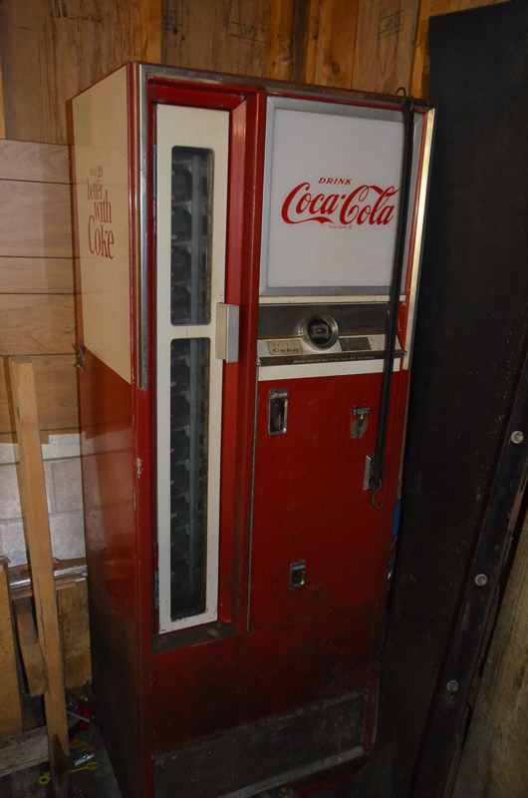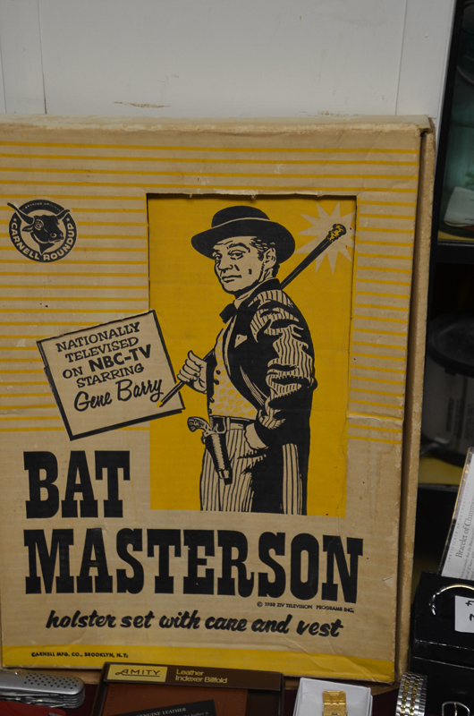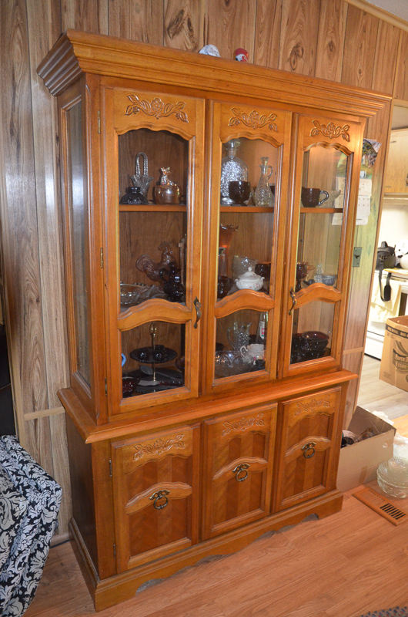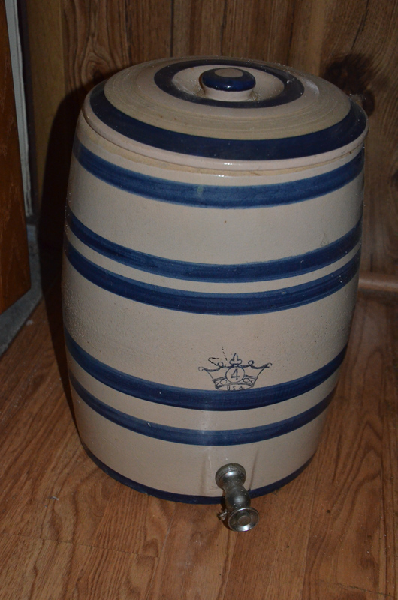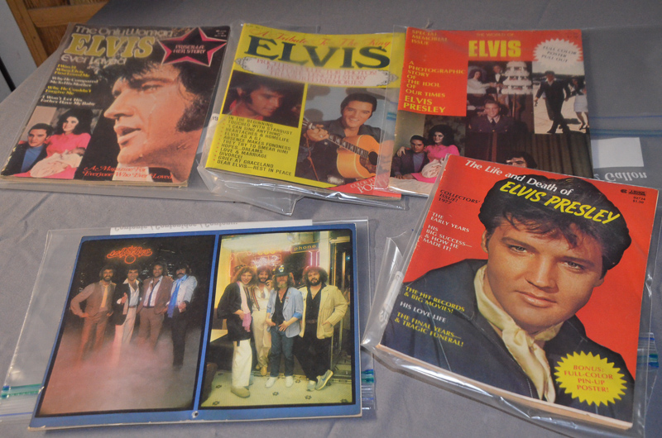

crates, dispenser, bank, 75th anniv. glassware+); Tom’s glass display jars w/lids + Toms; plastic Cookies display container, Pepsi and Dr. Pepper bottles; Pepsi electric wall clock; creamery bottles; motorcycle items ( Rough Roder lunch box, clock+); 1950’s Andy Gard Gee I Jeep in orig. box; NY jacket w/hat (XL), Mopar jacket (2XL); Nascar items (posters and MAXX card collection); Michael Jordan life size stand up cardboard cut out; vtg. razors & yo-yos, pocket knives (Uncle Henry, Sheffields, Swiss Army++), Desert Storm card series; advertising pieces (Anacin, Fairmont Ice Cream, Union 76 metal box+); Wall signs (Coca Cola, Red Devil, Sambo malted milk, Merita bread, Budweiser racing, 59 Ford Thunderbird, Dale Earnhart, Bill Elliott, Keystone/Coors beer; Wall clocks (Family drive in, Richard Petty, GE, United, Hot Rod, UVA+); metal milk crates & thermometers (Coca Cola, Dr. Pepper, Pepsi+); oil lanterns, cookie jars, Elvis magazines, pitcher & bowl sets, ceramic steins, 2 aluminum softball bats+
Furniture: 3pc. Bookcase ensemble (1 w/pull down desk), matching electric sofa recliner-love seat recliner-rocker recliner, matching coffee table & end table, DR table w/1 leaf & 6 chairs, china hutch, 6 gun cabinet, wall gun rack, bedroom set (bed, dresser w/mirror, chest and 2 end tables), brass full headboard w/frame, 4 dr. desk, computer desk w/hutch top, display racks, vintage metal glider w/chairs, TV stand/cabinet+,
Housewares: Glassware (Avon Cape Cod, iridescent Indiana/Carnival, Fire King, American Fostoria+), Wellesley china set, platters enamel ware, cookware, COOKS flatware set, Keurig, microwave, clocks & mirrors, sm. appliances (GF grilling machine, electric skillet+), numerous AVON collectibles, table & floor lamps, JVC stereo compact, DVD & VHS player, CD’s & DVD’, 60” flat screen TV, Cannon copier+
Tools/Misc: 2 shop vacs, portable air tank, step stool, Homelite 5500 generator, McCullough 10-10 chain saw, 2 floor jacks, 10’ aluminum ladder, Campbell Hausfield pressure washer, rolling shop table, All Pro 55,000 btu heater, Craftsman (30gal. compressor, 6’ grinder, circular saw, stackable tool boxes, grinder/polisher, compact compressor, heavy duty sandblasting system, riding mower grass catching system+), sockets, shop lights Big red shop stool, hedge trimmer, impact set, auto tune up analyzer, heavy duty drill, battery charger, transmission jack, car ramps, Weedeater, come along, load binders, pruners, RV waste pump, metal cabinets, 6’ vise, levels, wrenches, nuts, bolts, gloves, rope, Anchor brand clothes ringer+
Directions: I64W, take exit 10/Callaghan (VA 159S/US 60E); left onto Midland Trail Rd. (US-60W/VA 159); rd. changes name to Dunlap Creek Rd.; follow for 7+ mi.; follow signs. I64E, take Callaghan, exit 10; rt. onto Midland Trail Rd., see above.
Terms of Sale: Real Estate: 10% down day of sale, balance on delivery of deed within 45 days. Sold subject to owner confirmation. Personal Property: Cash, check or CC (proc. Fees apply), picture ID required. Announcements day of sale take precedence over printed material. Ltd. chairs available/bring a chair. Food provided by the Dunlap Fire & Rescue.
NO BUYER’S PREMIUM!!
Sale conducted for Judy Frame and the Late Wayne Porterfield by NICELY’S AUCTION CO
Brandon Nicely – Auctioneer #2620Va. Mike Jeffries – Auctioneer #4073Va. 425 Soldiers Retreat Rd., Eagle Rock, Va. 24085
540/862-0714 or 540/968-2568

