PUBLIC AUCTION  Saucon Valley Auction Company  Personal Property / Real Estate  3276 Route STE 212  Springfield Pa, 18081  610.972.6523  AUCTION: Saturday: Ju1y 22nd, 2017  11:00AM Real Estate | 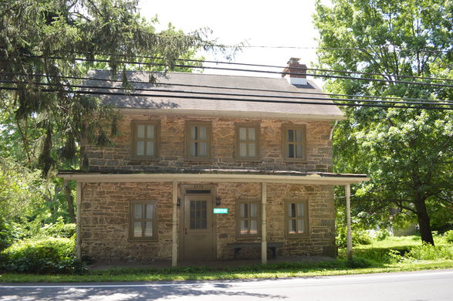
OPEN HOUSES: Wed. , July 5th 4-6 PM  Sunday, July 9th 12-2 PM  Wed. , July 12th 4-6 PM  Municipality – Springfield Township  County – Bucks  School District – Palisades  Lot Size – 2.4 +/- Acres, approx. 104.544 square feet  Parcel No. – 42-017-020  Deed Book / Page – | Zoning – R1- Low Density Residential  Year Built – 1956  Total Taxes $1.112.32*  County $733.12  Municpal $379.20  School * Unknown at this time  Assessment $31,600  Assessed Land $7,080  Assessed Improvements $24,520  Markey Value: $284,680
HOUSE  Construction – Old Colonial approx. 1920 square feet | Electric – 200 amp  Heat – : oil  Water – Public  Septic - Septic
1st Level  Room Size  Living Rm. 12’10” x 10’ 5”  Study/parlor 12’9” x 12’2”  Mud Room 12’2” x 7’6”  2nd Level  1st Room 17’3” x 9’3”  Bed Rm. 1 10’4” x 9’1”  Bed Rm. 2 12’ 7” x 12’ 10”  Bathroom 1 tub 10’8” x 5’9”  Bathroom 2 shower 6’3” x 6’3”  Pantry off Kitchen 9’7” x 8’  Kitchen – 17’ 3” x 15’  Unfinished Basement 1st portion 20’7” x 15’1”  2nd portion 24’8” x 8’11” | REAL ESTATE TERMS -  Ten (10%) Percent of the whole in cash or its equivalent, to be held in escrow by Saucon Valley Auction Company when the real estate is struck down; the balance on or before 45 days after auction. Buyers premium will be added to the final hammer price. Buyers premium is 2% if there is broker participation, with 1% going to the broker. Broker participation must be documented and verified by SVA no later than 72 hours before the advertised auction time. Buyers premium is 1% if there is no broker participation. The buyers premium will be deducted from the down monies collected day of sale and delivered at settlement.
Saucon Valley Auction Company  1901 S.12th St.  Allentown PA 18103  610.972.6523  svauction@live.com  AY002230 | 