Apartment Space Auction

For the estate of Larry Holcomb

Monday September 25th, 2017 @ 6:00pm

407 Kenna Drive #32, South Charleston, WV

Directions: From MacCorkle Ave in South Charleston at stoplight turn onto Kenna Drive. Unit #32 is located in 4th building on right – ground level. Watch for signs.

*** OPEN HOUSE SUNDAY 2-4PM ***

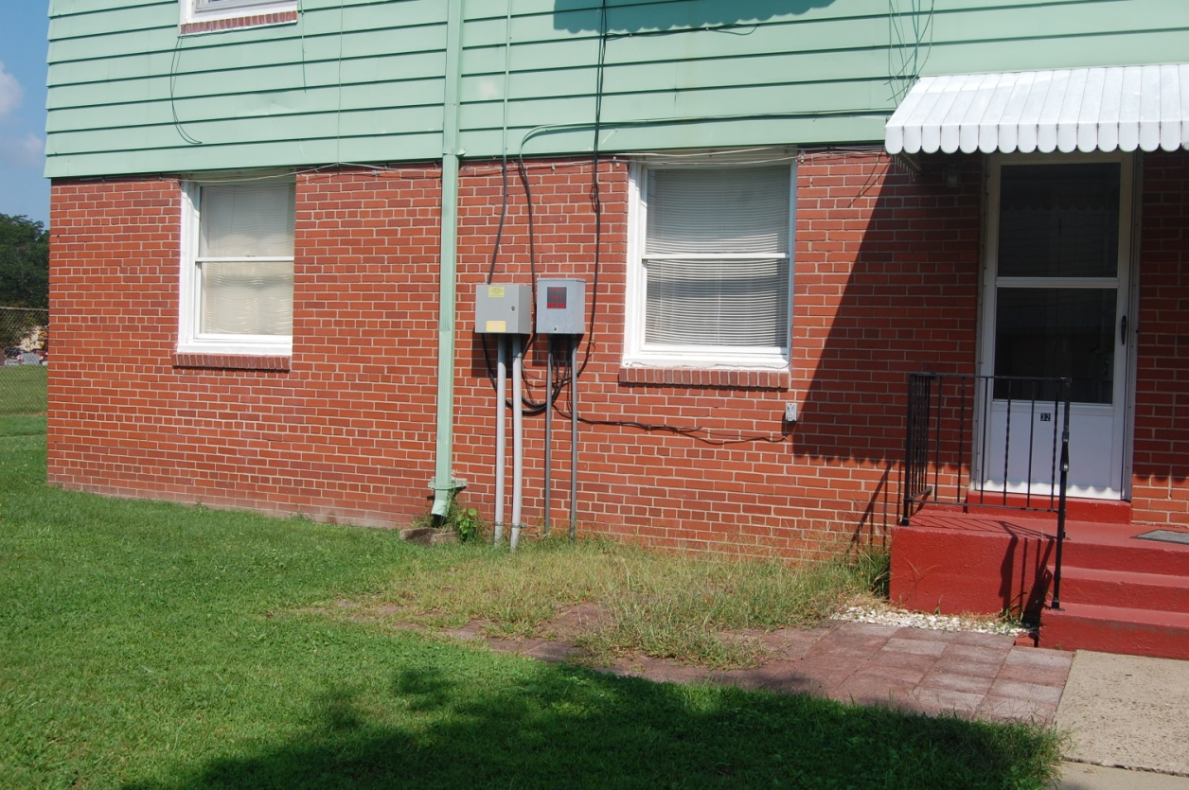

Auctioneer: Stacy L. Cooper #1517 Auctioneer/Agent: Roger Mullins #1703

www.MOUNTAINEERAUCTIONS.com

or www.auctionzip.com ID #4152 or #4158 for terms & photos

BEDROOMS: 2

BATHS: 1

SQ. FEET: Approx. 525 sq ft.

COUNTY: Kanawha
TYPE: Ground floor apartment
YEAR BUILT: Approx. 1941
WATER: City
WALLS: Sheetrock
WINDOWS: Insulated
FLOORS: Carpet, Tile, Linoleum
A/C: Central
SEWER: City
ADDITIONAL: Kenna Homes Cooperative Stock Certificate ownership – Monthly 2BR fees run approximately $338.00 and cover all primary utilities except phone.
***Interested parties please review all Cooperative information at http://www.kennahomes.com/information

