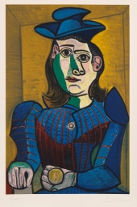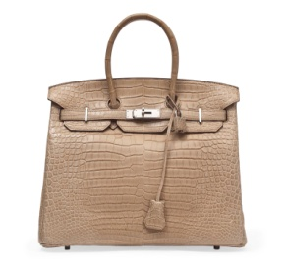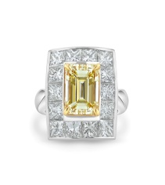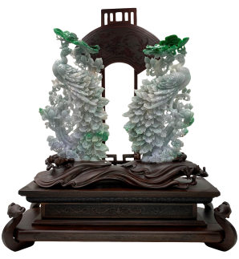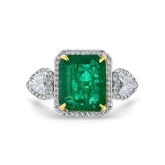

PUBLIC AUCTION
EXQUISITE JEWELRY AND FINE ART

DoubleTree Hotel
By Hilton Monrovia-Pasadena
924 west Huntington Drive, Monrovia, CA 91016

August 14, Sunday
ONE DAY ONLY!

Preview: 12:00pm Auction Start: 1:00pm

For directions: (626) 357 1900 * For Further info: 800-995 2282
Get a chance to win IPAD AIR plus other Raffle prizes!
www.primeauction88.com
Come and see Hundreds of Fine Art and Jewelry collections including GIA Certified Fancy Intense Yellow, Pink diamonds & Jade Jewelry as well as Certified Sapphire, Ruby & Emeralds.

A huge selection of Original Pierre Auguste Renoir, Salvador Dali, Henri Matisse, Marc Chagall, Pablo Picasso paintings. Bronze Sculptures* Handmade Silk & Wool Persian & Oriental Rugs * Fine European Furniture * Rolex , Patek Philippe and Chopard Watches * Hermes and Chanel Bags * Jadeite Carvings and other collectible art.

Food and beverage will be served.

Free gift and Raffle prizes. So Hurry and grasp this great opportunity!

FREE PARKING!
FREE ADMISSION!

*This company is not affiliated with any government agency.
*Auction Bond#5270717 * Auctioneer Bond#5270716

